

American International University-Bangladesh (AIUB)  
**Department of Computer Science  
Faculty of Science &Technology (FST)  
Summer 20_21  
CSC 2210 Object Oriented Analysis and Design (OOAD)**

**Section: K  
Group No: 07**

**ART GALLERY MANAGEMENT SYSTEM**

An Object-Oriented Analysis and Design (OOAD) project submitted

By

|  |  |  |  |
| --- | --- | --- | --- |
| Serial No. | Student Name | Student ID | Contribution |
| 07 | MD. HASIBUR RAHMAN | 20-42180-1 | 20% |
| 08 | MD. TANVIR RAHAMAN SHAFIULLAH | 20-42191-1 | 20% |
| 09 | ASIF ZAMAN | 20-42212-1 | 20% |
| 10 | FAHIMA MAHJABIN MIM | 20-42231-1 | 20% |
| 38 | ABU JUBAIR BIN AMIN | 20-43583-1 | 20% |

The project will be Evaluated for the following Course Outcomes

|  |  |
| --- | --- |
| **Project Marks Distribution** | Total Marks |
|  |
| Class Diagram and Sequence Diagram [5Marks] |  |
| Activity Diagram [5Marks] |  |
| State Diagram [5Marks] |  |
| Submission, Completeness, Spelling, Grammar and Organization [5Marks] |  |

## Class Diagram

**Case Study:**

In art gallery management system, there are two users, Admin and Customer. They have name and email in common. The customer and user have two states online or offline. There is a position for admin. There will be Art and Gallery. The gallery can count the visitors. A gallery can have at least one or many arts in their inventory. Every art has an id, category and price. Customer can buy art. If they want, they can order as much art as possible. Every order has their unique order no. One or many arts can be ordered. If customer buy art, they can pay with two several methods. If the customer wants, they can change their payment method and also can change their necessary information. The admin can manage one to many orders.

**Diagram:**

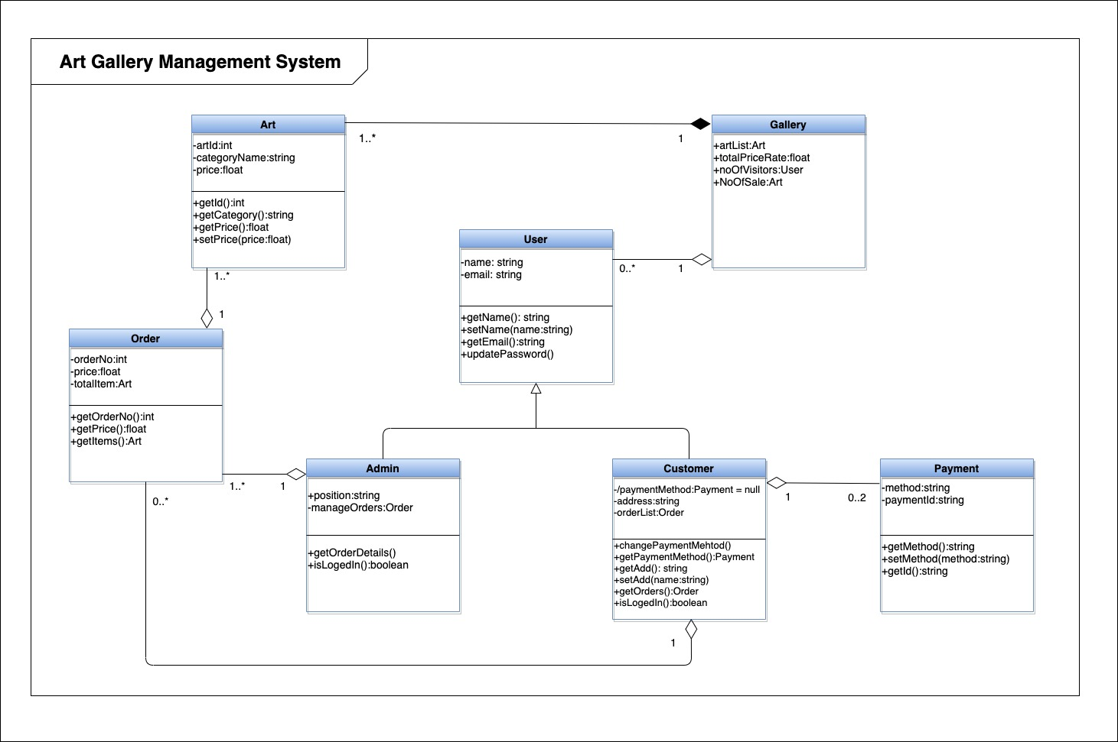

## Sequence Diagram

**Case Study:**

In an Art gallery management system, when a customer wants to login in a system, the system checks in the database is the customer is allowed to login or not. If the customer is allowed, the system returns to the customer that login is successful. After that in the browse interface, the customer can browse art gallery and select arts. After selecting the arts browse interface checks in the database if the art is available or sold. If available, it returns to the customer then they can purchase. Purchase interface get selected art from browse interface. Then it gets art’s info and price from the database and return to the customer. After that a customer can confirm, request for payment and select payment method in system. When payment processing is done, payment interface returns to the system that payment is successful. Then a booking is generated and return the conformation to the customer. If the art is sold, the system returns the art is not available for purchase. They can log out from the system. In case if the customer is not allowed to login, the reason is notified to the customer.

**Diagram:**

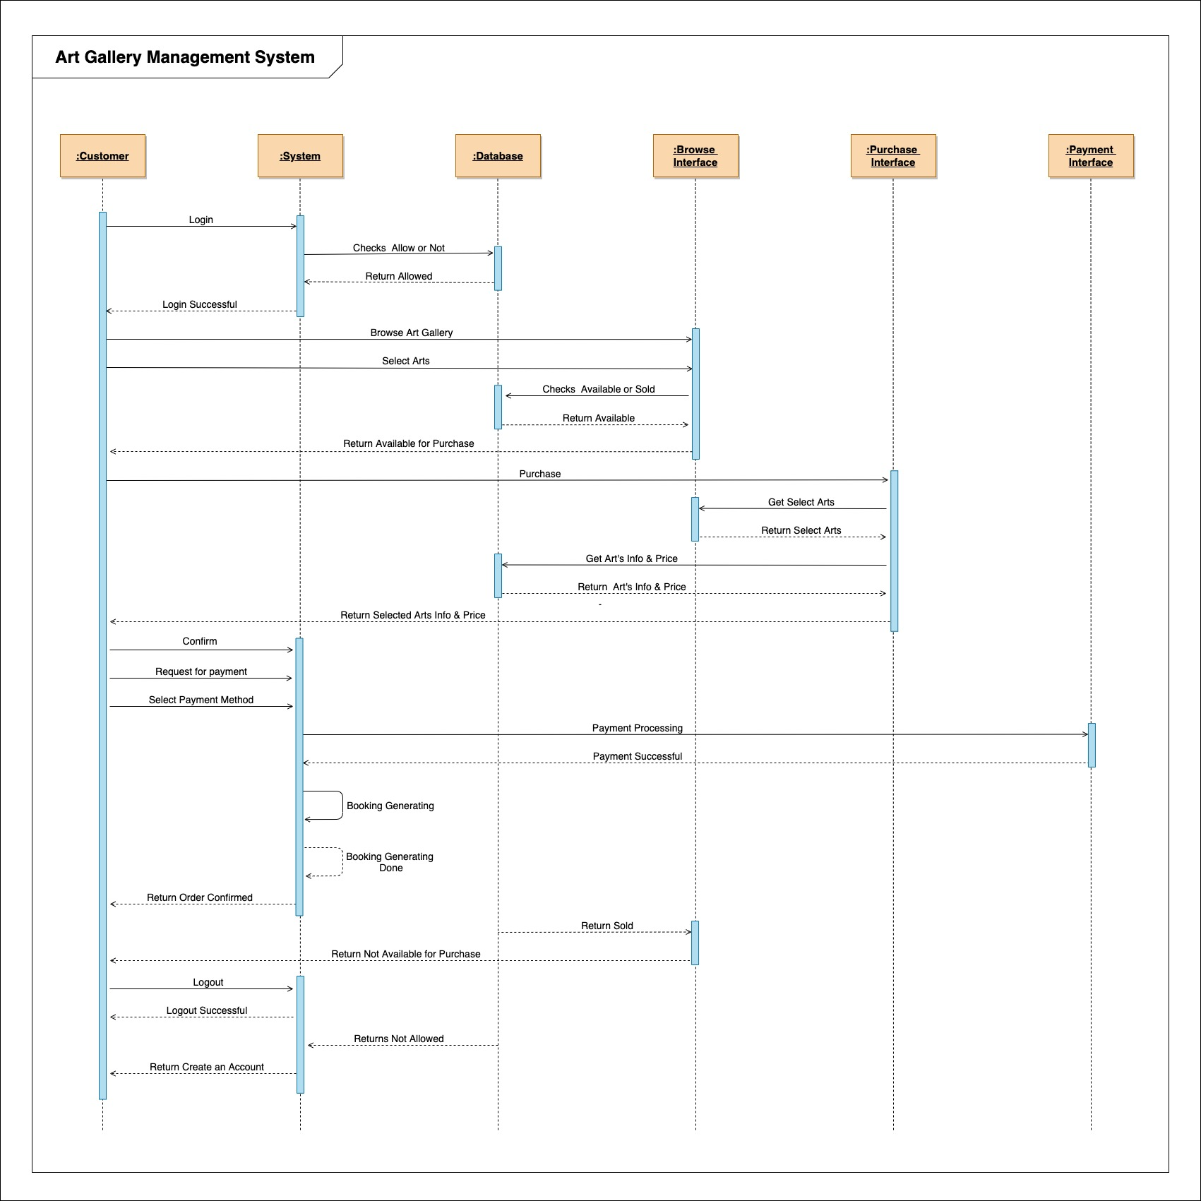

## Activity Diagram

**Case Study:**

In an Art gallery management system, when a customer wants to login in a system, the system checks the customer is allowed to login or not. If the customer is allowed, they can browse art gallery and select arts. When they select arts, it checks in the database if the art is available or sold. If available, the customer can purchase. Then they can see art’s info and price also. After that can request for payment. A customer has to select payment method, enter account number and enter the code at the same time. After giving the information they can confirm. Then it checks account number is valid or not. If it is an invalid number, it shows to the customer that it is an invalid account number and it will be redirected to request for payment option. But if the number is valid, it further checks the balance is greater or equal than the total amount. If yes the order will be confirmed but if no, it will show to the customer that insufficient balance and will be redirected to purchase option. In case if the customer is not allowed to login, the reason is notified to the customer.

**Diagram:**

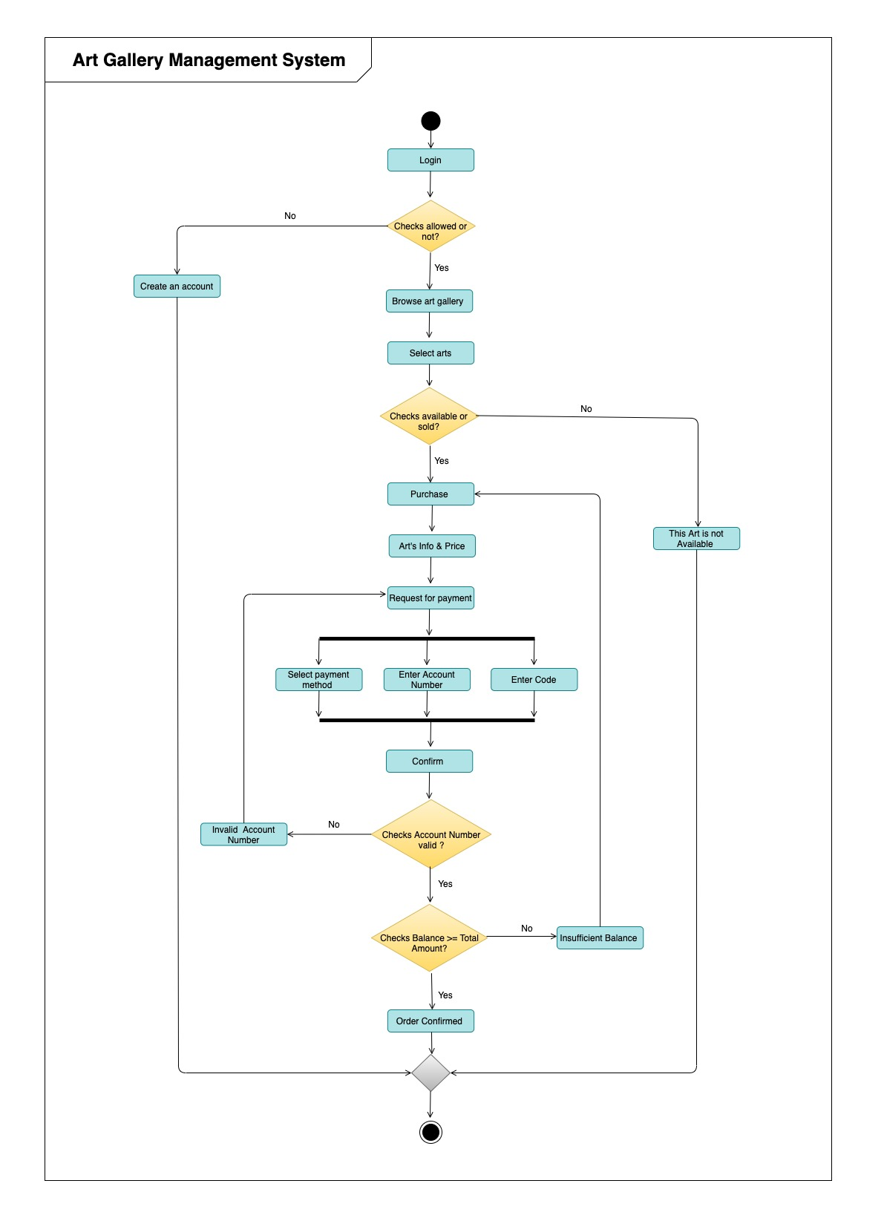

## State Diagram

**Case Study:**

In the Art gallery management system, the Art object is entered in the system when it is added in the inventory of gallery. Instantly this is available for purchase. So, the customer can buy the art. When they proceed ART is added in their cart. The user can proceed to pay for the art if their account balance is enough to buy that art. If they have enough balance then the ART is confirmed and instantly it goes to delivered state. If they don’t have enough balance the ART is canceled to buy.

**Diagram:**

